Creating the meta datasets
In the creating the meta datasets folders, there are 5 R scripts; 4 that create a meta dataset for each waste stream individually and 1 that just combines these into one large dataset. Each dataset is written to a csv file in the folder. Each row represents a country-waste stream, and below is the information that is stored/calculated with reasoning for their calculation. Note these quantities are calculated based on 2018-2022 being the test set, and 2023 being the first value forecast (as done for rest of the work).
- Country – identifying what the observation corresponds to
- Optimal model – identifying what the observation corresponds to
- 2023 forecast error (signed, so can be minus) – for colouring PCA plot
- 2023 forecast error (absolute value) – for colouring PCA plot
- PI width at 2023 – for colouring PCA plot
- Number of covariates taken – related to complexity of the model
- Training set standard deviation – representing the noise of the data trained on
- Test set standard deviation– representing the noise of the data tested on
- Ratio of the test to training standard deviation (test/training) – representing the noise of the data / if the noise is consistent across training and test
- Slope of the full dataset – identifier of trend
- Slope of the training set – identifier of trend
- Difference between slope of full dataset and training set – is the trend of the training set ‘misleading’ (does it change in the test)
- Binary indicator of sign change between full and training slopes – not used in PCA, calculated as it was easy to do
- Maximum absolute change in the whole series (jump/drop from t to t+1) – identifies instability in the data
- Mean absolute change in the whole series (jump/drop from t to t+1) – identifies instability in the data

Meta Modelling
Here, we perform PCA. The number of covariates, training sd, test sd, sd ratio, full slope, training slope, difference in slope, max absolute change and mean absolute change are used to calculate the PCs. The data is scaled and centred prior to this (best practice, done within PCA call, gotten from lecture notes). Then, the first 2 PC scores of the meta dataset are calculated. The PC1 and PC2 scores are plotted against each other to identify clusters. The PI width is used to colour them. Shapes are included to identify what waste stream each dot is (not sure if this is too much). The country labels are also printed.
The first two principal components explain approximately 69% of cumulative variance, providing an adequate low-dimensional representation of the predictor space for exploratory purposes.
The PC1 loadings can be interpreted as series instabilty. The strongest positive variable loadings in PC1 are train_sd (0.480), slope_full (0.367), slope_train (0.431), and mean_abs_change (0.315), indicating high PC1 scores are associated with series that are historically volatile, strongly trending, and characterised by large average year-on-year movements. The slope_diff loading (-0.416) is negative and moderately strong, suggesting that cases with high PC1 scores also tend to show a reduction in trend between the training period and the full series, consistent with series that were trending during training but whose trajectory changed near the forecast horizon.
PC2 is less easily interpretable. The strongest loadings are sd_ratio (0.431), test_sd (0.450), max_abs_change (0.448), and mean_abs_change (0.431), all positive, alongside negative loadings on slope_full (-0.342) and slope_train (-0.257). PC2 therefore appears to capture cases where the test period is relatively more volatile than training, with large episodic jumps, but without a strong underlying trend. This may correspond to structurally unstable series that are noisy rather than trending.
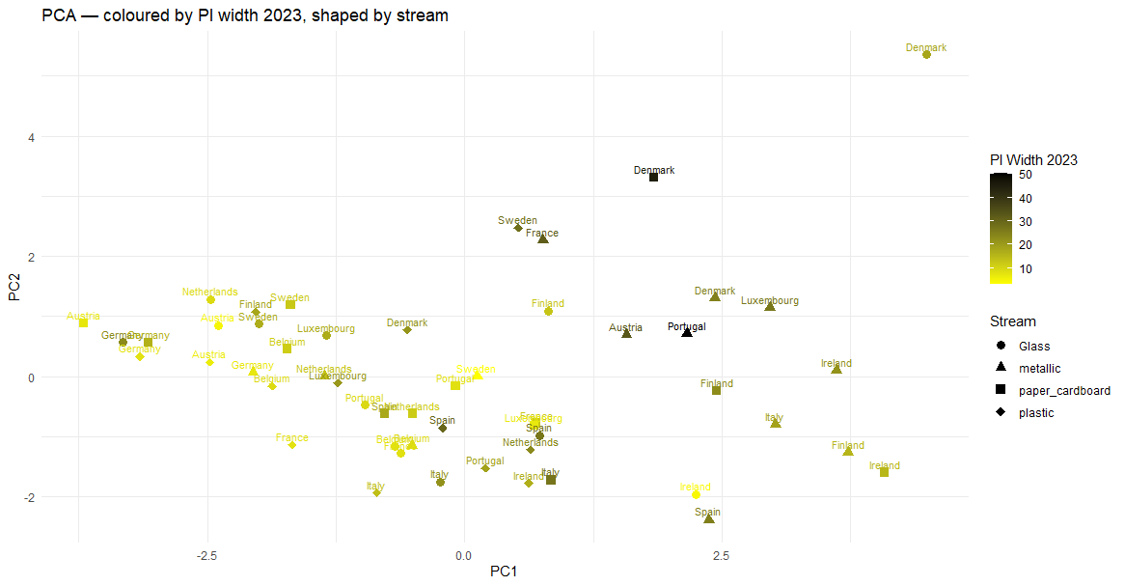
Most country-stream combinations cluster densely in the left-hand portion of the plot, characterised by low PC1 scores and consistently narrow prediction intervals as indicated by the yellow colouring. The shapes reveal that this left cluster is dominated by glass circles and plastic diamonds, confirming that these streams exhibit relatively stable historical trajectories.
Moving rightward along the PC1 axis, prediction interval width increases, with the darkest points generally concentrated on the right. The metallic values (triangles) are notably dispersed. Several sit in the right-hand portion of the plot with moderately wide PIs, consistent with the higher historical volatility observed in that stream in the visual narrative. The paper and cardboard squares show a similar pattern, with Denmark, Finland and Ireland paper and cardboard all sitting to the right with wider intervals. Given the interpretation of PC1, it seems that wider PIs correspond to series that are more unstable (expected result).
Denmark glass is the most extreme case in the entire dataset, sitting as a clear outlier in the top right corner, well separated from all other observations on both PC1 and PC2. This is consistent with its exceptionally high train_sd and max_abs_change driven by the extreme values recorded in the 2009-2010 period. Portugal metallic and Austria metallic sit at PC1 approximately 2.5 with dark colouring, identifying them as high instability cases with wide PIs, consistent with the known 37-point forecast error for Portugal metallic.
An important caveat should be noted. First, this analysis is explicitly exploratory and descriptive. The patterns observed should be interpreted as suggestive rather than conclusive.

